Phase 5

Lesson 4

**Build a Custom Docker Image**

**This section will guide you to:**

* Build a custom Docker image using a custom Dockerfile and deploy it on Docker host.

**Prerequisites:**

* Docker must be installed on your system.

**Steps:**

1. Clone Git repository

2. Docker Build

**Step 1:** Clone Git repository

* First, clone the Git repository on a Docker host using the command below:

**git clone** [**https://github.com/Anuj1990/Docker.git**](https://github.com/Anuj1990/Docker.git)

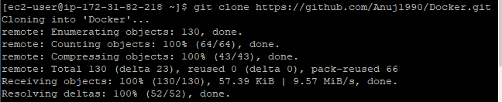

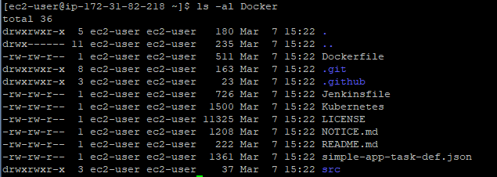

**Step 2:** Docker Build

* Then, proceed with the docker build command to build a custom docker image.

**cd Docker**

**docker build -t phpcode .**

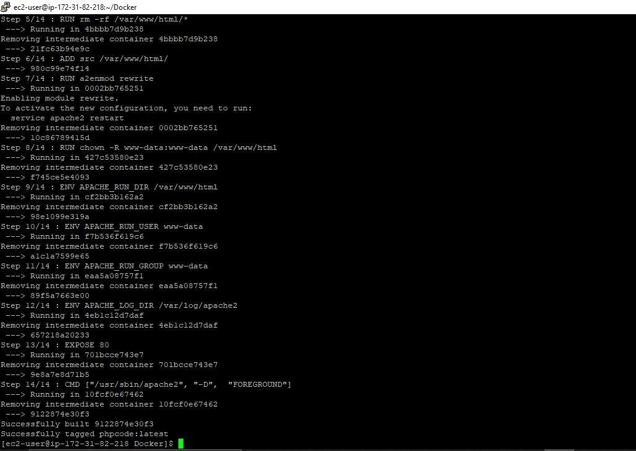

* Once the image is built, check the image using docker run command and then run it to initialize custom container on Docker host.

**docker images**

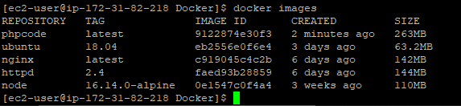

**docker container run -d --name phpcode -p 80:80 phpcode**

